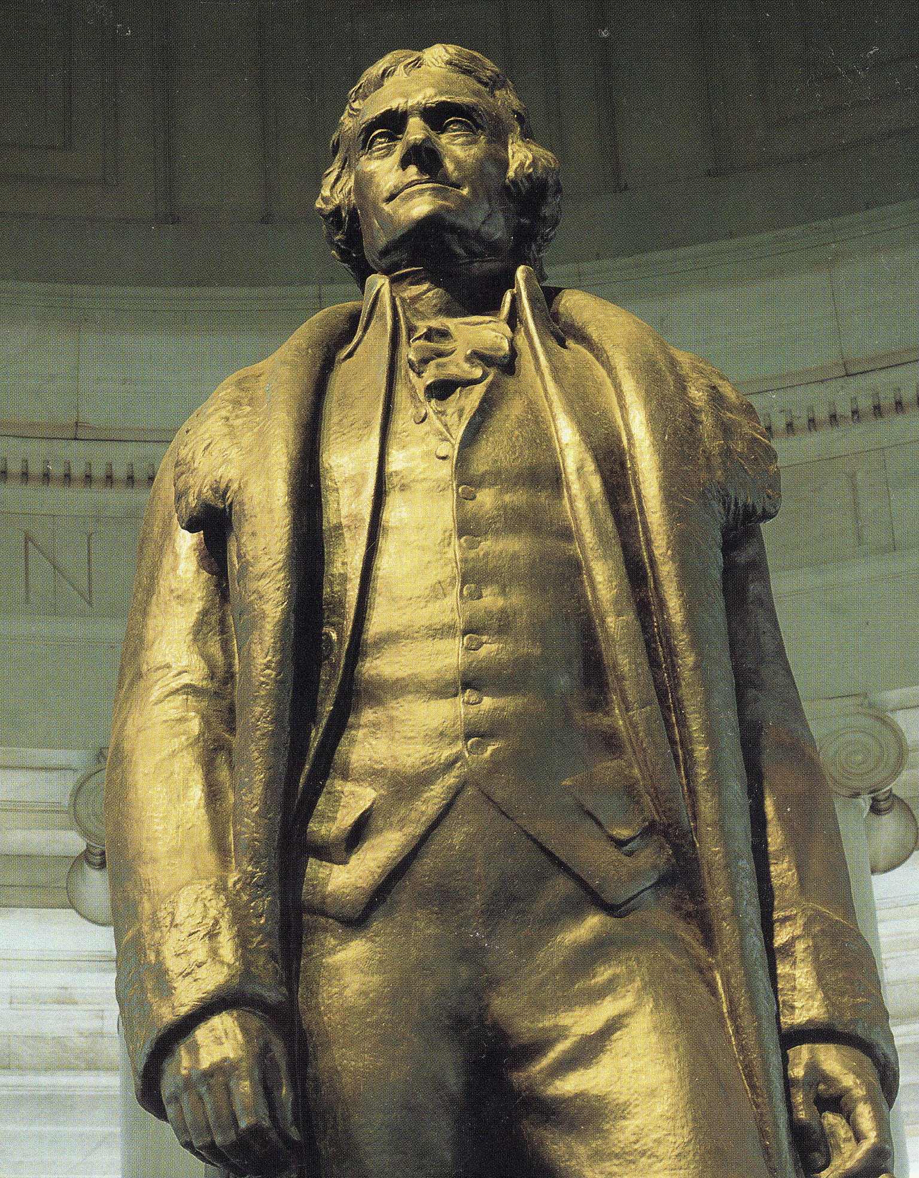

Landmark Supreme court Cases

2014-2015 Brady’s AP GOVERNMENT CLASSES

AP Government
Landmark U.S. Supreme Court Case Studies

The cases listed below are 105 of the landmark decisions reached by the United States Supreme Court. It is likely that some of these cases will appear on the AP exam. Each student was assigned one case from the list below and wrote a legal brief concerning it. The directions stipulated that each brief must be typed and must not exceed a single sheet of paper. The title of the case was to be centered at the top of the page and the student author’s name should appear in the upper right-hand corner. The five parts of the legal brief were to be addressed in a section heading that is capitalized and underlined as follows:

FACTS: What happened in the case?

ISSUE: What is the Supreme Court asked to decide? What is the Constitutional question?

ARGUMENTS: What are the primary arguments advanced by the Supreme Court to reach its decision?

DECISION: What did the Supreme Court decide? The decision must be related to the issue above.

IMPLICATIONS: What were, are, or might be the effects of the decision?

THE CASES

1. Abington School District v. Schempp (1963) - School prayer
2. Alden v. Maine (1999) - State immunity in Federal Courts
3. Baker v. Carr (1962) - Apportionment
4. Barron v. Baltimore (1833) - Constitution federal not state
5. Bethel School District No. 403 v. Fraser (1986) - Lewd speech not protected at school
6. Betts v. Brady (1942) - Right to counsel
7. Bowers v. Hardwick (1986) - Gay rights
8. Brandenburg v. Ohio (1969) - Freedom of speech/KKK
9. Brown v. Board of Education of Topeka (1954-55) - Separate but unequal
10. Buckley v. Valeo (1976) - PACs and cash as free speech
11. Bush v. Gore (2000) - The decision to end the recount
12. Communist Party v. Subversive Activities Control Board (1961) - Registration
13. Cox v. Louisiana (1965) - Civil disobedience
14. Dickerson v. United States (2000) - A Miranda case

15. Dred Scott v. Sanford (1857) - Slavery and citizenship
16. Edwards v. Aguillard (1987) - Creationism
17. Engle v. Vitale (1962) - Nondenominational prayer
18. Escobedo v. Illinois (1964) - Confession when counsel denied
19. Everson v. Board of Education (1947) - Parochial busing
20. Furman v. Georgia (1972) - Death penalty
21. Gibbons v. Ogden (1824) - Interstate commerce
22. Gideon v. Wainwright (1963) - Right to counsel
23. Gitlow v. New York (1925) - Free speech and press
24. Good News Club v. Milford Central School (2000) - Religious use of school facility
25. Gregg v. Georgia (1976) - Death penalty
26. Gregory v. Chicago (1969) - Due process
27. Griswold v. Connecticut (1965) - Right to privacy
28. Hammer v. Dagenhart (1918) - Child labor laws
29. Hazelwood School District v. Kuhlmeier (1988) - Students and freedom of press
30. Humphrey’s Executor v. United States (1935) - Executive branch and FTC
31. Jones v. Mayer (1968) - Race and real estate
32. Katz v. United States (1967) - Surveillance
33. Korematsu v. United States (1944) - Japanese internment
34. Lee v. Weisman (1992) - Clergy can participate in graduation
35. Lemon v. Kurtzman (1971) - Public salary subsidies of private school teachers
36. Louisville Bank v. Radford (1935) - Bankruptcy
37. Marbury v. Madison (1803) - Judicial review
38. Mapp v. Ohio (1961) - Admissibility of illegally obtained evidence
39. McCulloch v. Maryland (1819) - Federal supremacy
40. Minersville School District v. Board of Education (1940) - Flag and pledge case
41. Miranda v. Arizona (1966) - Accused must be informed of rights
42. Mitchell v. Helms (2000) - Federal monies for private schools
43. Munn v. Illinois (1887) - State legislated grain prices
44. Near v. Minnesota (1931) - Freedom of press
45. New Jersey v. TLO (1985) - Search and seizure in schools
46. New York Times v. Sullivan (1964) - Libel standards for press
47. New York Times v. United States (1971) - Pentagon Papers
48. Planned Parenthood v. Casey (1992) - Abortion case
49. Plessy v. Ferguson (1896) - Separate but equal
50. Printz v. United States (1997) - Brady background checks
51. Reed v. Reed (1971) - Sex equity
52. Regents of the University of California v. Bakke (1978) - Race-based quotas
53. Reynolds v. Sims (1964) - Malapportionment
54. Reynolds v. United States (1879) – Polygamy case/establishment clause
55. Roe v. Wade (1971) - Abortion
56. San Antonio v. Rodriguez (1973) - School finance via property tax

57. Schechter Poultry Corp. V. United States (1935) - Interstate commerce
58. Schenck v. United States (1919) - Clear and present danger
59. Shaw v. Reno (1993) - Majority/Minority districts
60. Sheppard v. Maxwell (1966) - Conflict of Constitutional rights
61. Terry v. Ohio (1968) - Appropriateness of search
62. Texas v. Johnson (1989) - Flag burning
63. Tinker v. Des Moines School District (1969) - Peaceful student protest
64. United States v. Eichman (1990) - Flag burning
65. United States v. Leon (1984) - Exclusionary rule
66. United States v. Lopez (1995) - Gun Free Zones Act
67. United States v. Nixon (1974) - Executive privilege
68. United States v. Virginia (VMI) (1996) - Gender-based education
69. United States v. Won Kim Ark (1898) - Citizenship
70. United Steel Workers of America v. Weber (1979) - Private, voluntary quotas
71. Wallace v. Jaffree (1985) - One minute period of silence
72. West Virginia State Board of Education v. Barnette (1943) - Mandatory pledge
73. Wisconsin v. Yoder (1972) - Religion and public education
74. Wolf v. Colorado (1949) - Abortion
75. Zorach v. Clausen (1952) - Leaving school for religious instruction
76. Kelo V. City of New London (2005) - The controversial eminent domain case.
77. Elk Grove Unified School District v. Newdow (2004) - The “Pledge” case.
78. District of Columbia v. Heller (2007) - Second Amendment case.
79. Citizens United v. Federal Elections Commission (2008) - Free Speech/Political Speech.
80. Grutter v. Bollinger (2002) – Race basis for Michigan’s Law School Applicants.
81. Gratz v. Bollinger (2002) – Race basis for undergraduate admissions.
82. MCConnell v. FEC (2002) – “Soft money” ban on contribut-
ions legal?
83. Fisher v. Texas (2012) University of Texas Admissions Case.
84. United States vs. Windsor (2013) DOMA and Same Sex Marriage.
85. Florida v. Harris (2012) 4th Amendment and search dogs.
86.Maryland v. King (2012) 4th Amendment and DNA samples
87.Holder v. Gutierrez (2011) Resident status of minors/citizenship.
88. McDonald v. Chicago(2009) Does 2nd Amendment apply to states through incorporation?
89. Baker v. Nelson (1971) Legal right to gay marriage?
90. Morse vs. Frederick (2007) Bong hits for Jesus case!

91. McCutcheon vs. FEC (2013) Aggregate limits on campaign contributions?
92. Burwell vs. Hobby Lobby Stores (2014) Religious Freedom/Health coverage?
93. Michigan vs. Bay Mills Indian Community (2013) Indian Gaming and Land rights.
94. Paroline vs. The U.S. (2013) Restitution Case.
95. Salinas vs. Texas(2012) A 5th Amendment Case.
96. Miller vs. Alabama (2011) An 8th and 14th Amendment Case.
97. Davis vs. U.S. (2010) Good Faith Exception in arrests?
98. Wal-Mart vs. Dukes(2010) Equal Pay Case
99. Arizona Christian School Tuition vs. Winn (2010)-Establishment Clause
100. U.S. vs. Playboy Entertainment (1999) FCC and Decency Case.
101. Brown vs. Plata (2010) Prisons and Cruel and Unusual Punishment
102. Department of homeland Security vs. McClean (2014) Whistleblower Protection Act.
103. T-Mobile South, LLC vs. City of Roswell Georgia (2014) Cell phone towers in neighborhoods?
104. Swann vs. Charlotte-Mecklenberg BD. Of Ed. (1970) Busing as a remedy to segregation?
105. Alabama Legislative Black Caucus vs. Alabama (2014) Redistricting Case.

ADDITIONAL INTERNET RESOURCES: Please Only Use these sites

www.scotusblog.com (Site related to official site. Easy to use)
www.supremecourtus.gov (The official site)

http://supct.law.cornell.edu/supct (The great site at Cornell University)

http://supreme.lp.findlaw.com/supreme_court/resources.html (Easy to use)

http://oyez.org (The Northwestern University site.) (My personal favorite)

